1. Google for i2cdevlib or go to the link below: <https://github.com/jrowberg/i2cdevlib/tree/master/Arduino>
2. Download the folders “MPU6050” and “I2Cdev”
3. Move these two folder into the “Arduino\libraries” folder where you installed (or the root directory of) your Arduino. (ex: PC C:\Program Files (x86)\Arduino\libraries) (Mac document\Arduino\Libraries)
4. Connect an Arduino board with MPU6050 as shown below:

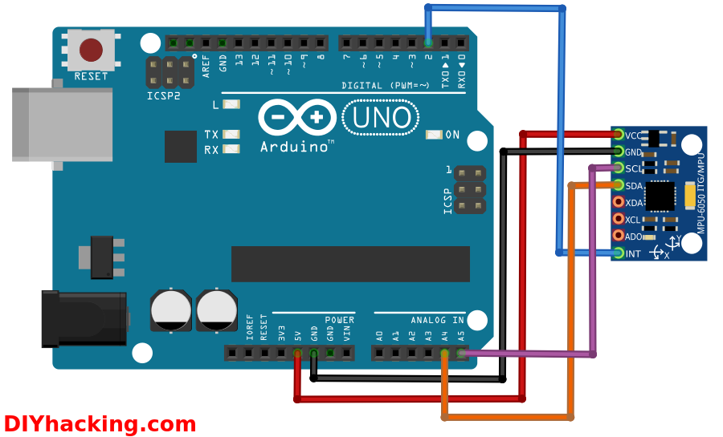

1. Upload the Arduino sketch “CalibrateMPU6050.ino” onto the Arduino board above. (This sketch should be in this tutorial folder. Created by [luisrodenas](https://www.i2cdevlib.com/forums/profile/1113-luisrodenas/))
2. Place the MPU6050 horizontally on the table.
3. Open up the serial monitor of the Arduino IDE.

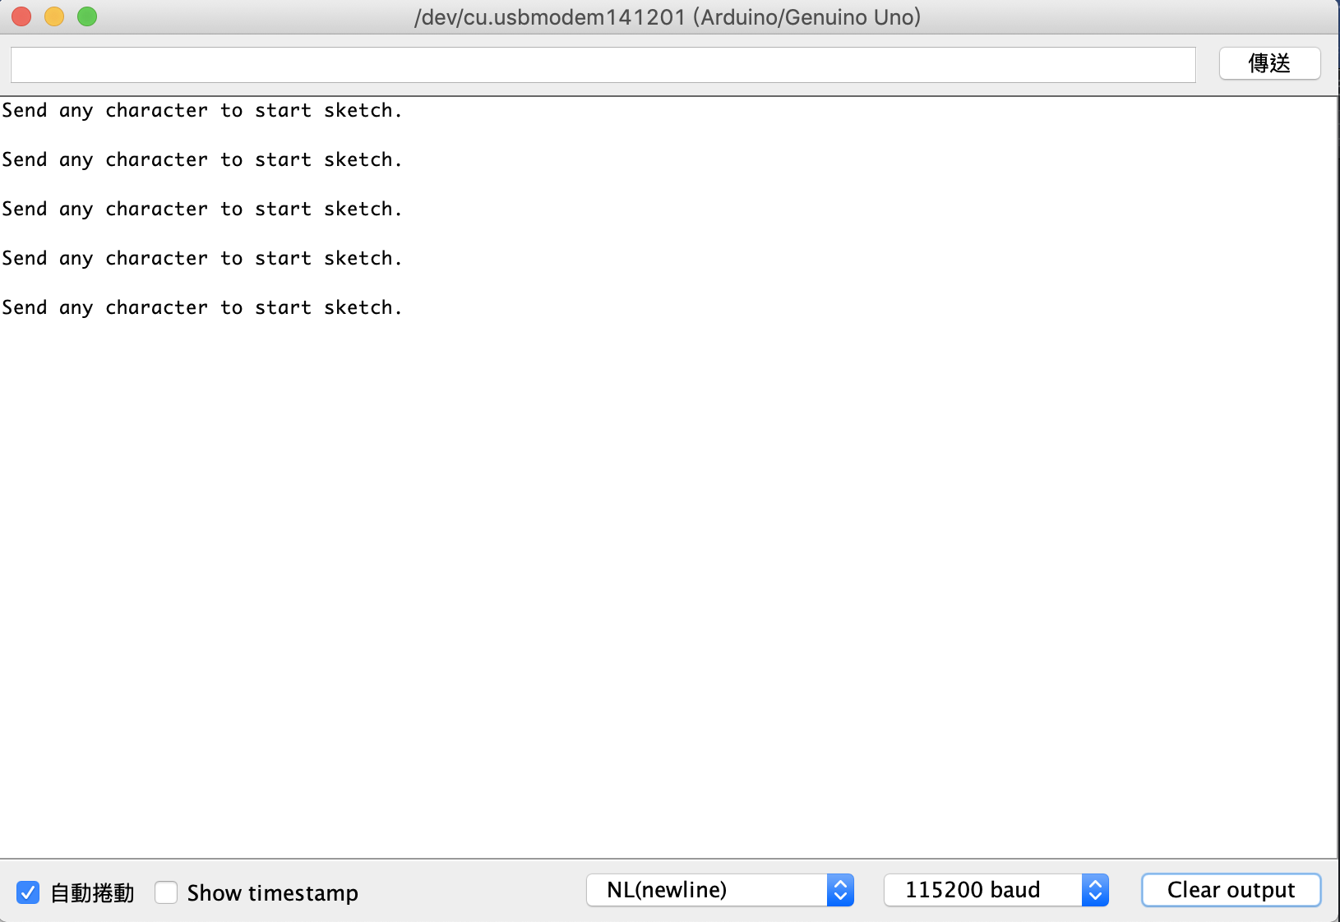

1. Hit any key and press “Enter”
2. Wait until the message “FINISHED!” appears.

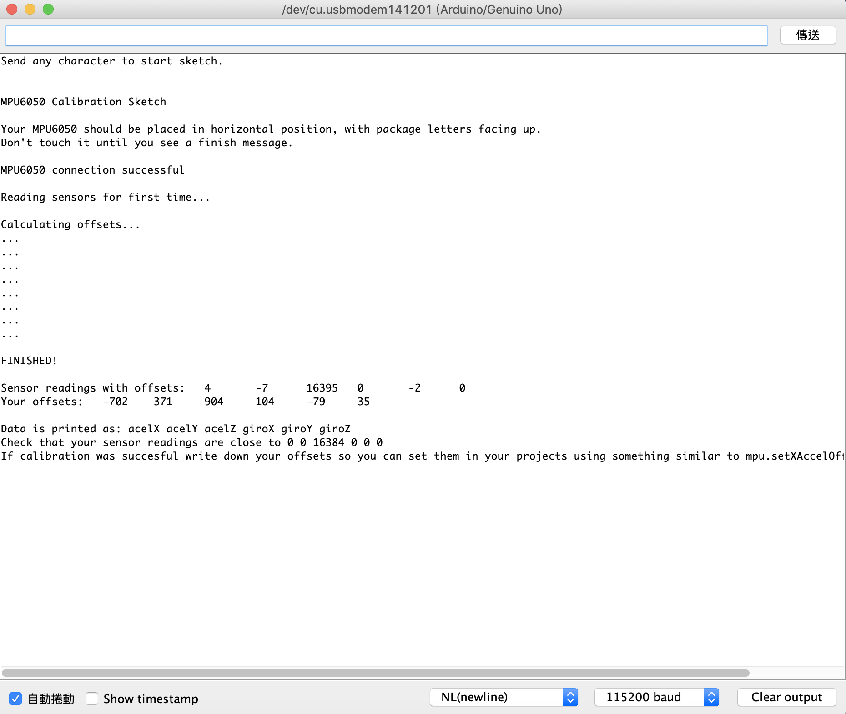

1. Open the sketch MPU6050_DMP6_KCH.ino. (In the template folder of this tutorial packet.)
2. Use the values behind “Your offsets: ” in the serial monitor to set the proper offset values in MPU6050_DMP6_KCH.ino. Each MPU6050 has its own unique (normally non-changing) offset values.

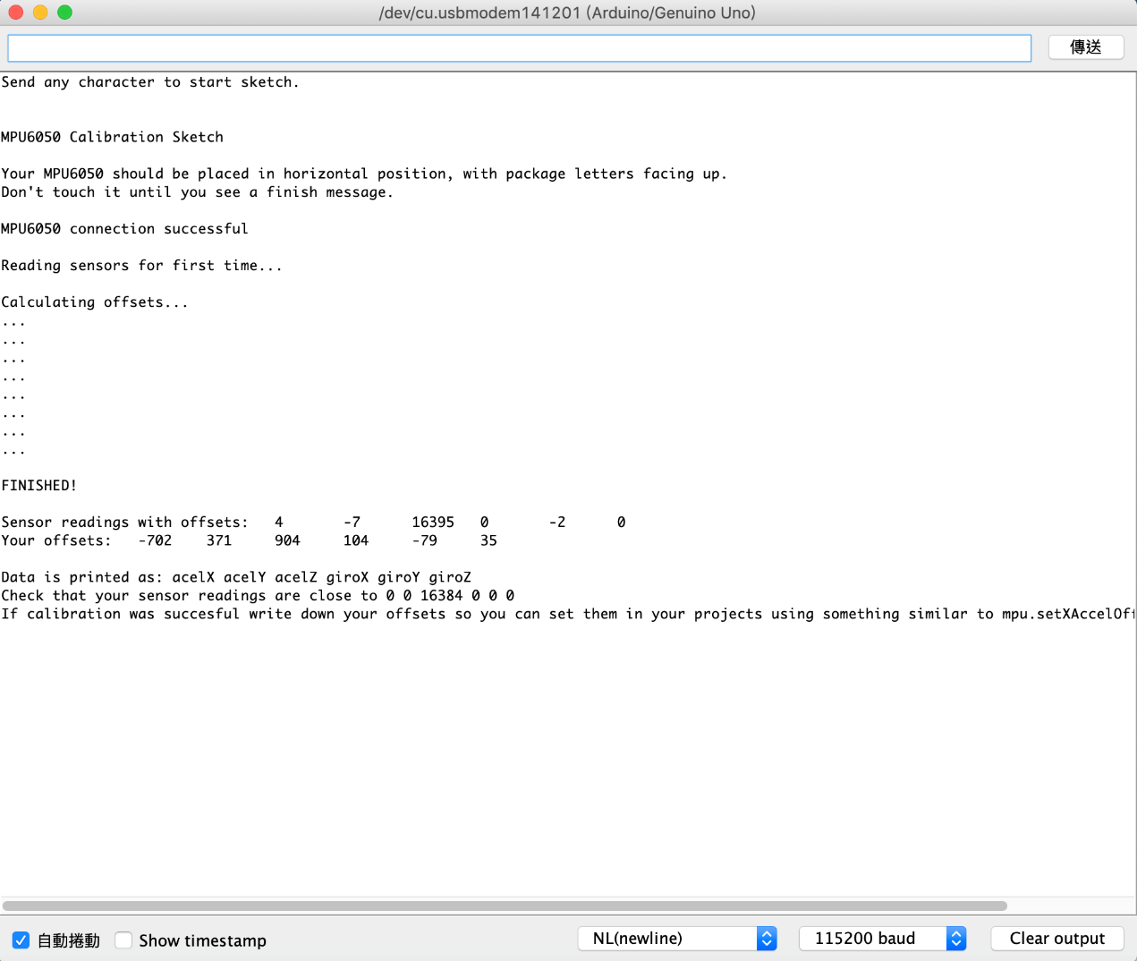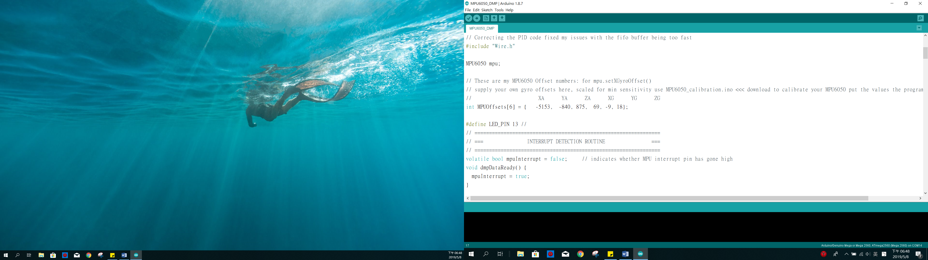

1. Upload sketch onto the Arduino board to check if the sketch runs properly. (By default, Arduino should be printing yaw, pitch, roll values to the serial monitor)
2. Modify MPU6050_DMP6_KCH.ino to fit the needs of your project.